**NASA GRC Laboratory Infrastructure Data Collection**

**User Manual**

1. **Overview**

The NASA GRC Laboratory Infrastructure Data Collection Tool is a web-based application built using Streamlit, an open-source Python framework. The purpose of the tool is to capture the current state of GRC capabilities. This information is necessary to assess the overall state of our infrastructure and assets and will be used to develop strategic plans for laboratory investment. The tool can be accessed via: <https://nasagrclabdatabase.streamlit.app/>

1. **Definitions**

|  |  |
| --- | --- |
| Laboratory | Dedicated facility, or dedicated infrastructure, for performing a specific type of testing, research, or development. A laboratory may encompass a unique capability and may include multiple high values assets such as test or analytical equipment (e.g., The Structural Dynamics Laboratory). |
| Asset | Unique equipment that is segregable from the facility. An asset may be composed of multiple components. (e.g., a Scanning Electron Microscope). |

1. **General Instructions for Users**

Using the web-app, users should fill out each field for an individual lab and its assets. Assets should only be added to the record if it is associated with the infrastructure of the lab and not the facility. To limit the total number of entries, users should only enter assets that have a value over $50,000 or assets at lower values that are either extremely critical to the lab’s capability or are difficult to replace. Entries made by each user can be saved to the database as either a draft or a final submission, such that users can save their work and come back to it to further edit at a later date.

**Note: Entries in the database are indexed off of the “Laboratory/Capability Name”, and therefore must be unique for each entry. If data is changed for an entry and the “Laboratory/Capability Name” is kept the same, the data will be overwritten, and if the “Laboratory/Capability Name” is changed, a new record will be created in the database.**

For questions regarding the data collection tool, please contact Brandon Hearley (LMS) at [brandon.l.hearley@nasa.gov](mailto:brandon.l.hearley@nasa.gov).

1. **User Login**

To access the database and data collection tool, users need an “access code” supplied by a database administrator. If you do not have an access code or forgot the access code, please contact [brandon.l.hearley@nasa.gov](mailto:brandon.l.hearley@nasa.gov). On the home page, enter the access code and press ‘Enter’ to submit. If the access code is correct, the data collection tool will open. If it is incorrect, an error message will display (Figure 1).

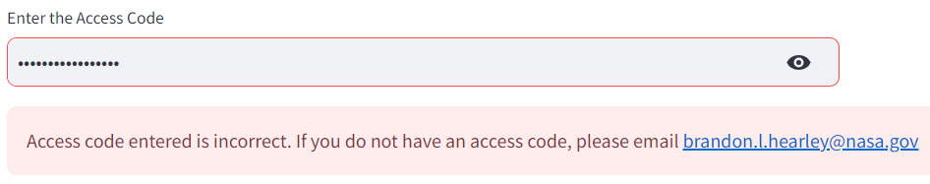

Figure . Entering the Access Code

1. **Data Collection**
2. **Loading Data from the Database**

Data can be saved and loaded from the database, allowing users to save their work and return to it at a later date or use an existing record as a template. To access data in the database, use the “Load From Database” button to create the “Select the Lab” drop down menu. **Note: the first instance of pressing “Load From Database” may briefly show the drop down menu and then disappear from the screen. If pressed again, the drop down menu will return.** Users can scroll through the drop down menu or type in the text entry under “Select the Lab” to find an existing record (Figure 4). When selected, any populated fields in the database will automatically load into the data collection tool.

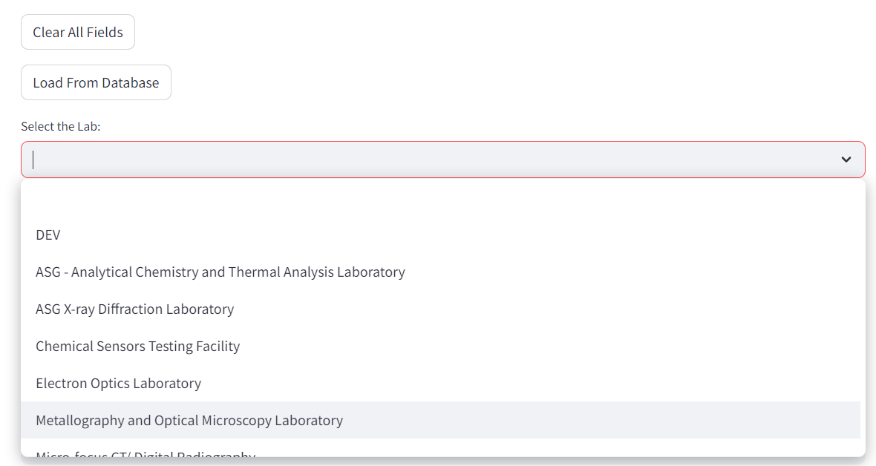

Figure . Load data from the database to populate the data collection tool with an existing record

1. **Laboratory Information**
2. General Information

The Laboratory Information section is used to collect information about the lab itself. Each field can be entered by the user to capture the relevant data. Some attributes have help icons ( ) that will display additional information if hovered over by the user. The data collected in this section contains (Figure 5):

|  |  |
| --- | --- |
| Laboratory/Capability Name | The name of the lab or capability. This field must be populated to save to the database. **If left empty, the following error message will be displayed, and no data will be saved.**    **Note: Entries in the database are indexed off of the “Laboratory/Capability Name”, and therefore must be unique for each entry. If data is changed for an entry and the “Laboratory/Capability Name” is kept the same, the data will be overwritten, and if the “Laboratory/Capability Name” is changed, a new record will be created in the database.** |
| Point of Contact | Point of contact for the lab. |
| Branch | The branch associated with lab. This field must be populated with the 3 Letter code for the branch. **If left empty or not in the correct format, the following error message will be displayed, and no data will be saved.** |
| Laboratory Capability/Description | A description of the lab or capability. |
| Laboratory/Capability Website | Website for the lab (if applicable) |
| Challenges in sustaining this laboratory/capability | Field to enter and describe any challenges in sustaining the laboratory/capability. |
| Age | The age of the lab. |
| Condition | The overall condition of the lab (Choices: Excellent, Good, Fair, Poor). |

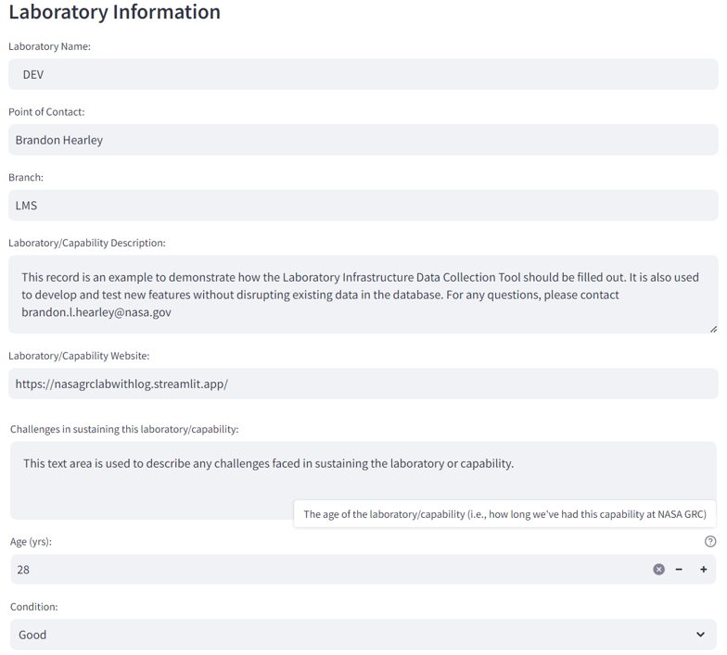

Figure . General Laboratory/Capability Information

1. Defining Assets

In this section, users also enter individual asset information. The “Number of Assets” field is used to create the Asset Table, where the number entered corresponds to the number of rows created (Figure 6). The fields in the Asset Table are:

|  |  |
| --- | --- |
| Asset Name | The name of the asset. |
| Location (Bldg/Rm) | The location (building and room number) of the asset. |
| Age (yrs) | The age of the asset. |
| Acquisition Year | The year the asset was acquired by NASA GRC. |
| Expected Year of Obsolescence | The expected year that the asset will be obsolete. |
| Asset Condition | The condition of the asset (Choices: Excellent, Good, Fair, Poor). |
| Replacement Cost ($) | The estimated cost to replace the asset. |
| Impact to Capability if Lost | The impact the lab/capability if the asset is los. |
| Associated Software/Required OS | A list of any required software or operating systems need to run/use the asset. |
| Includes IT Hardware? | Does the asset include IT hardware? (Yes/No) |
| Replacement Parts Available? | Are replacement parts available for the asset, or would a full replacement be needed if the asset were to fail. |

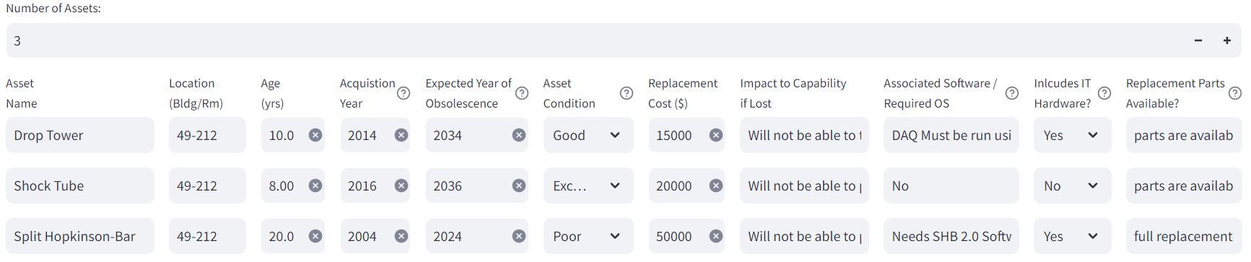

Figure . Asset Information

1. Defining Asset Images

For each asset defined, images associated with the asset can also be added. To add new images, editing the “Number of NEW Asset Images” field will create the Upload Asset Images Table (Figure 7). The Upload Asset Images Table contains:

|  |  |
| --- | --- |
| Asset | Drop down menu of the assets defined in the Asset Table. Select an asset to associate it with the image uploaded. |
| Images | Selection tool to upload an image. Note: only one image can be uploaded per row. To upload multiple images for one asset, create additional rows using the “Number of NEW Asset Images” field. Images are limited to 200 MB per file. |
| Notes | Field to enter any notes associated with the image |

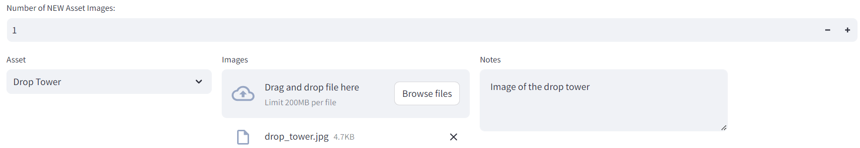

Figure . Upload Asset Images

To view/edit any images that have already been uploaded to the database, expand the “View/Edit Existing Asset Images in the Database” drop down (Figure 8). This container will display any images that already exist for that record. The asset and notes sections can be edited by the user and saved to the database. To delete an image, use the drop down menu on the far right of the container to change the entry from “Keep” (default value) to “Remove”.

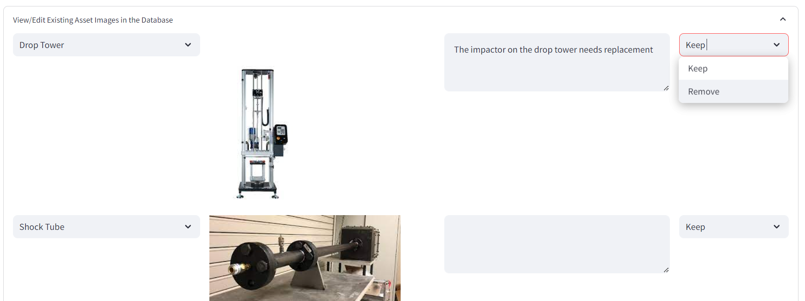

Figure . View/Edit Asset Images

1. Funding Information

The funding information section contains a text area to describe the “Sustainment Funding Source”, as well as the Funding Source Table (). Rows are added to the Funding Source Table by changing the “Number of Funding Sources” field. The Funding Source Table contains:

|  |  |
| --- | --- |
| Funding Source | The funding source. |
| Funding Start Date | The start date for funding. **Note: Dates must be entered in MM/DD/YYYY format. The web-app will provide a calendar selector tool and populate the date in the correct format.** |
| Funding End Date | The end date for funding. **Note: Dates must be entered in MM/DD/YYYY format. The web-app will provide a calendar selector tool and populate the date in the correct format.** |
| Funding Amount per Year ($) | The amount of funding per year |

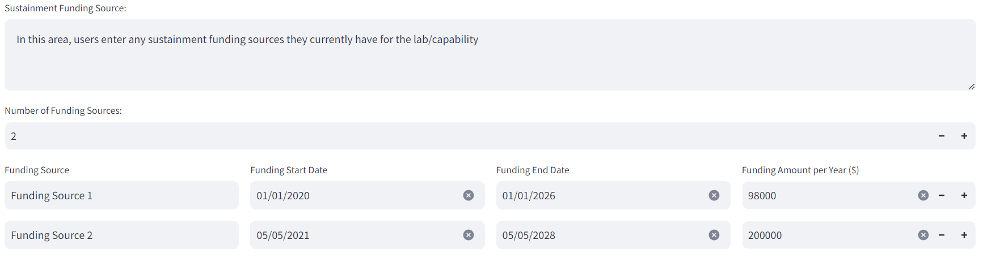

Figure . Funding Information

1. Laboratory Images

General lab images can be added to the database using the “Upload New Laboratory Images” field (Figure 10). Multiple files can be added at once using the “Browse files” button. To view/delete images that have already been uploaded, expand the “View/Edit Existing Laboratory Images” drop down menu, which will display all images associated with the lab and the option to “Keep” or “Remove” the image. Changing the drop-down menu option to “Remove” and saving to the database will delete the image from the record.

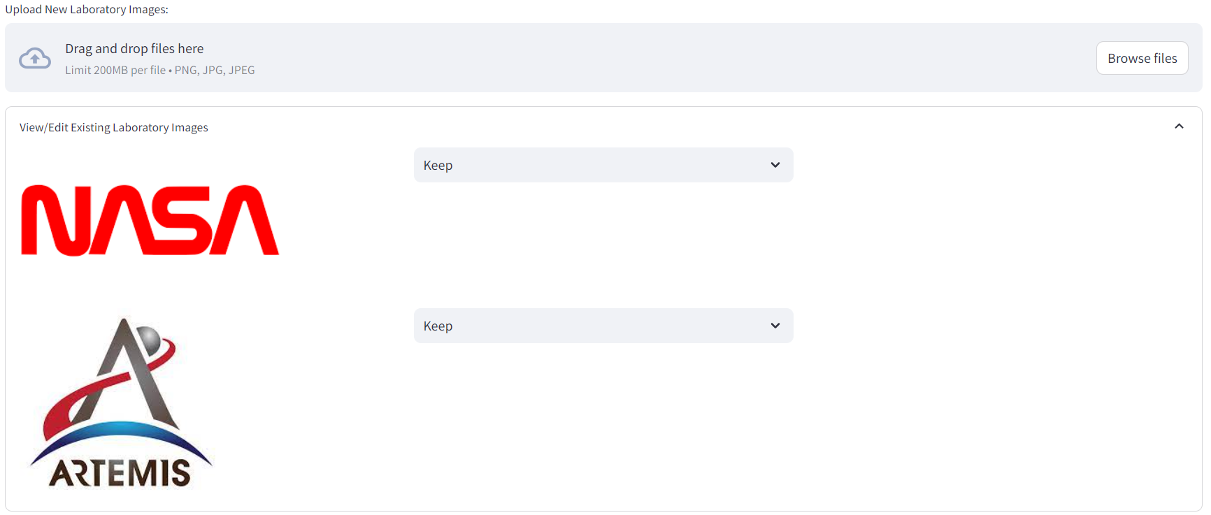

Figure . Laboratory Images

1. **Current Mission/Project Utilization**

The Current Mission/Project Utilization section is used to capture the current utilization of the lab in NASA Missions (Figure 11). To add rows to the Project Information Table, edit the “Number of Projects” field. The Project Information Table contains:

|  |  |
| --- | --- |
| Mission/Project Name | Mission or project name. |
| WBS Number | The WBS number for the project. Only the first 6 digits are necessary |
| Project Use (%) | The amount of time (by percent) that the project uses the lab’s capabilities |
| Risk to Project | The risk to the project. Choices are High, Moderate, or Low.  High - Capability cannot be replicated elsewhere and replacement has high cost/lead time.  Moderate - Capability cannot be replicated elsewhere and replacement has low cost/lead time.  Low - Capability can be replicated elsewhere for low cost/lead time |
| Impact if Laboratory/Capability is Lost | Impact to the mission/project if the capability is lost. |

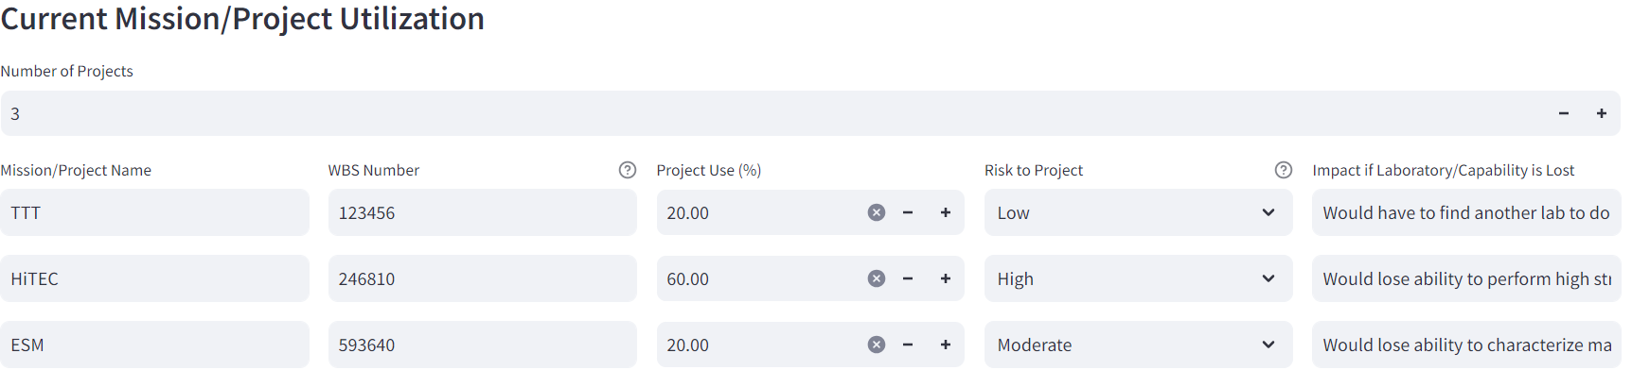

Figure . Current Mission/Project Utilization

1. **Utilization History and Impact**

The Utilization History and Impact section gives users the ability to describe the previous successes of the lab with regards to NASA missions and the impact of the lab or capability is lost (Figure 12). The section contains fields for:

|  |  |
| --- | --- |
| History of capability utilization | Previous history of use of the lab/capability. |
| Major impact and contributions this capability has made possible. | Description of the major impact and contributions this capability has made possible with regards to NASA missions/efforts. |
| Overall impact if laboratory/capability is lost | Impact to future NASA missions/efforts if the lab or capability is lost. |

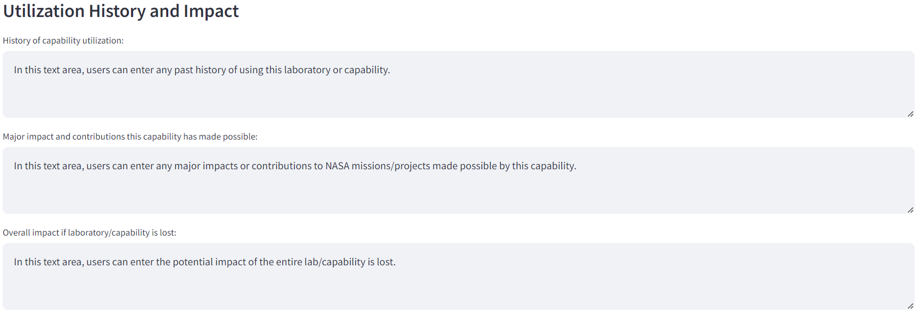

Figure . Utilization History and Impact

1. **History of Down Time Due to Maintenance or Failure**

The History of Down Time Due to Maintenance or Failure section is used to document any prior failures for the lab or individual assets. To add rows to the Down Time Table, edit the “Number of Rows” field (Figure 13). When filling out the Down Time Table, **only consider failures relevant to the failure of the lab infrastructure that occurred within the last 5 years.** The Down Time Table contains:

|  |  |
| --- | --- |
| Asset | Drop down menu for the asset that experienced the failure. Options will include “Entire Lab/Capability” and the assets defined in the Asset Table. |
| Start Date | The start date for the failure. **Note: Dates must be entered in MM/DD/YYYY format. The web-app will provide a calendar selector tool and populate the date in the correct format.** |
| Time Down | The duration of the failure. |
| Unit | The associated unit for the duration of the failure (Choices are Days, Weeks, Months, Years). |
| Impact on Mission/Project | The impact the failure had on NASA missions/projects. |
| Additional Notes | Any additional notes on the failure, including what caused the failure, what could have been done to prevent the failure, etc. |

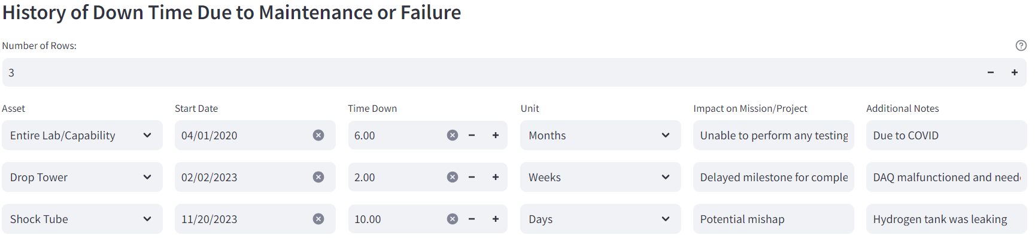

Figure . History of Down Time Due to Maintenance or Failure

1. **Cost**

The Cost section allows users to identify associated costs with running and maintaining the lab (Figure 14). It contains:

|  |  |
| --- | --- |
| Estimated Cost to Replace Entire Laboratory/Capability ($) | The estimated cost to replace the entire lab and all assets, or to replace the capability as a whole. |
| Cost of Service Contracts ($) | The cost of the service contracts for all assets. |
| Annual Cost to Operate and Sustain the Lab ($/yr) | The annual cost to operate and sustain the lab. |
| Incurred Cost for Downtime ($/yr) | Any incurred costs per year due to failures/down time. |

The cost section also defined the division of labor costs. To add a row to the Labor Cost Table, edit the “Number of Divisions (Labor Costs)” field. The Labor Cost Table contains:

|  |  |
| --- | --- |
| Directorate | The directorate that uses the lab/capability. |
| Labor Cost (%) | The relative percentage that directorate uses the lab/capability. |

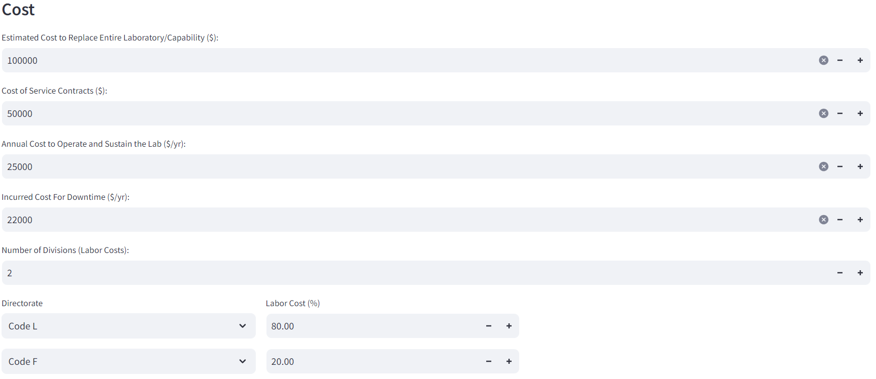

Figure . Cost

1. **Saving and Deleting Data**
2. **Saving Data**

Data is saved to the database using the “Save To Database” button at the bottom of the page (Figure 15). Data can be saved as either a Draft or Final by changing the “Completion Status” Dropdown menu.



Figure . Saving/Deleting Data

When saving data:

* If any errors are present, they will display below the “Save to Database” button and the data will not save to the database.

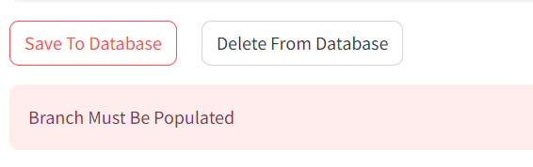

* When the data has written to the database, a “Saved to Database!” message will appear below the “Save to Database” button. If this message does not appear, your data did not save and refreshing the page will delete all previous entries.

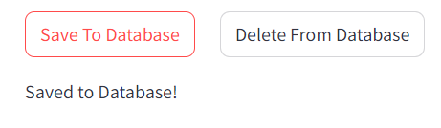

1. **Deleting Data**

Records can be deleted from the database by selecting the “Delete From Database” button. Any record that contains the value entered in “Laboratory/Capability Name” will be deleted from the database when pressed.

**If data is accidently deleted, please contact** [**brandon.l.hearley@nasa.gov**](mailto:brandon.l.hearley@nasa.gov)**. Backups of the database are performed daily, so records can be restored if necessary.**